System modeling

Team 7 심우석 – 201636417

전수환 – 201835519

박한음 – 201835461

1. **Scenarios**

First, we need to define the system boundaries. For Example, there is a book loan / return system that should be in a library management program. Conversely, parts such as a database of books or personal information of users will be linked to the program.

In addition, the program will be implemented while the program is envisioned using Agile development.

**1.1 A usage scenario for the Library Operating Program.**

James is a University student living in Seongnam, Gyeonggi-do. He went to the library in front of the house to prepare for the upcoming exam.

After arriving at the library, he logged in through the library operating program to study in the reading room. And he reserved a seat in the reading room. After that, when he was notified that his seat was assigned, He entered the reading room and started studying.

While studying his major, He did not know the something, so he went to the library to borrow a book. He entered the keyword “Software Engineering” into the library operating program’s book search box at the entrance to the library. Several books have been searched,

The location of the book was printed to borrow Professor Jeong Ok-ran’s book “Basic Software Engineering”.

He went to the A3 area to find a book. After arriving, he found the book, but there was no book. So, James asked the administrator about the book. Then the administrator ran a library operation program and searched for a loan for “Basic Software Engineering”. The program said it was currently lending. He asked the administrator to book the book. The administrator told him that a loan could be made in a week.

After a week, he borrowed the book he had booked and studied hard. Then, he forgot that he had borrowed the book, but a text message came to ask him to return the book that he had borrowed on his cell phone. After a while, James went to return the book and returned it through the library operating program. The program informed us that it was impossible to borrow for the next six weeks because the return period was delayed by three weeks.

1. **Interaction models**

**2.1 Use case diagram**

Based on this diagram, user information and search books using the management system, and librarians edit and manage book lists using the management system and database.

* 1. 지도, 테이블, 책상, 전체이(가) 표시된 사진

     자동 생성된 설명**Sequence diagram**

The user first finds the book and gets the information, then sends the loan request to the system. The system sends a loan completion message to the user and changes the loan status on the loan list. The librarian later checks this out. The librarian also connects to the database, checks the list of books, and then adds and deletes the designated books.

**3 Structure models**

**3.1 Class diagram**

The objects were divided into users, librarians, databases, libraries, loans, registrations, searches, and books, and indicated what each object would do and what attributes should be included.

1. 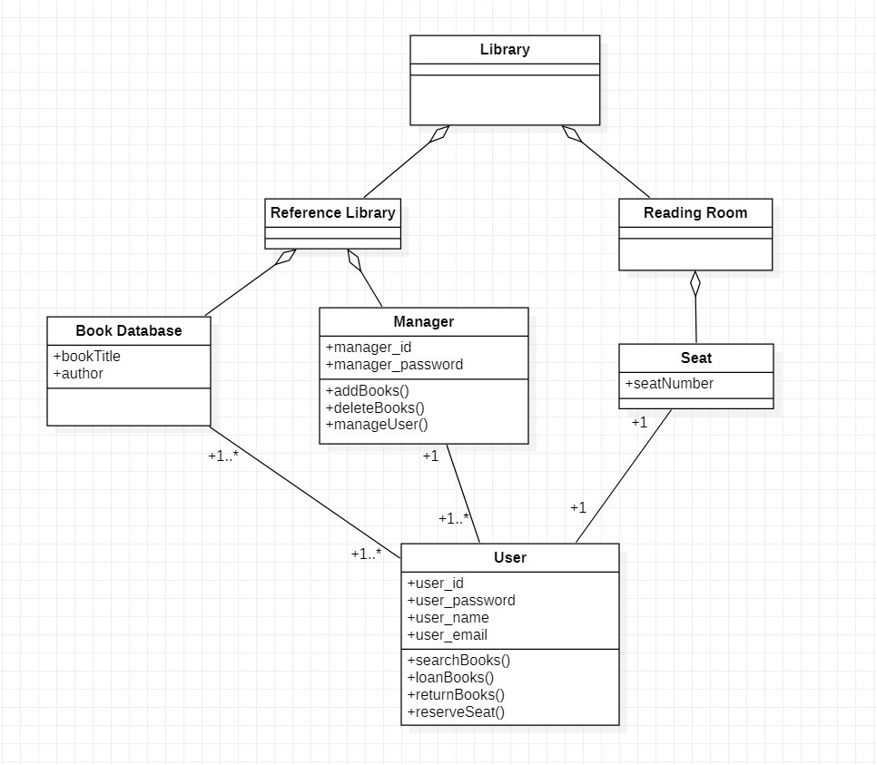**Object Class Aggregation**
2. **Activity Model**
   1. 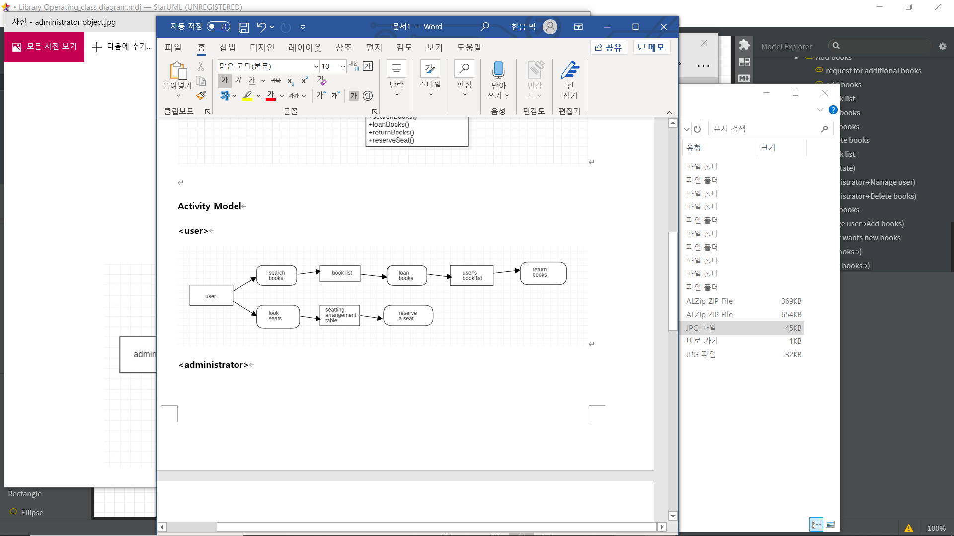**<User>**
   2. 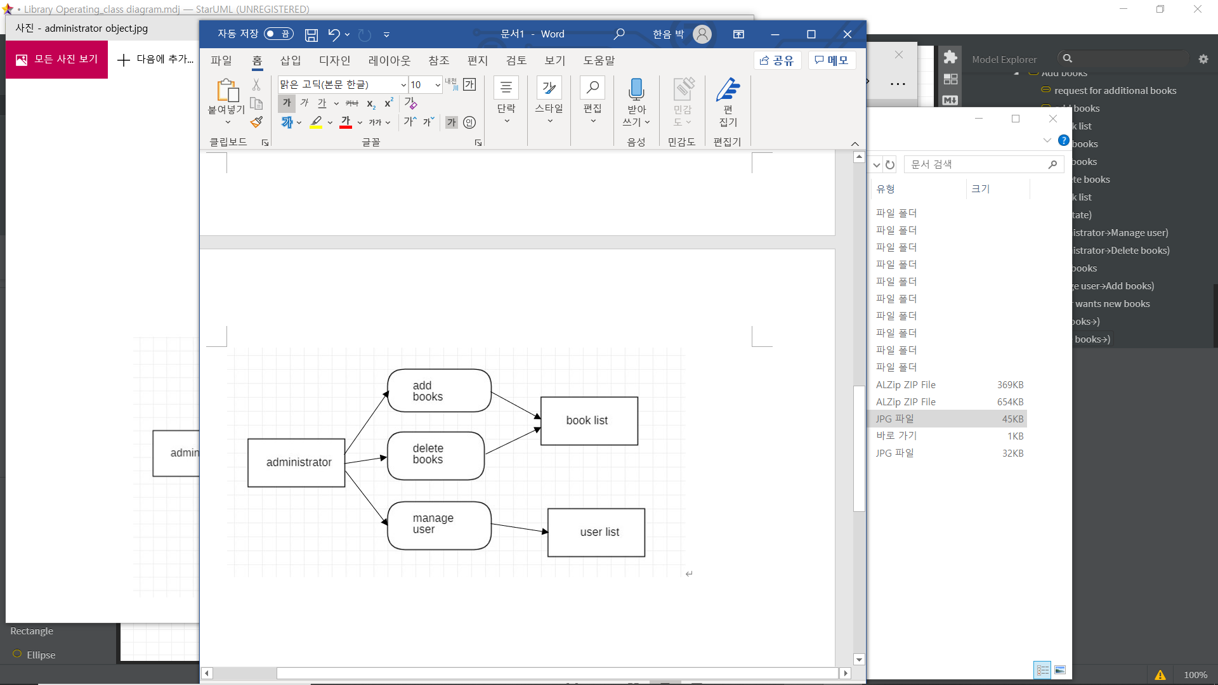**<Administrator>**
3. **State diagram**
   1. 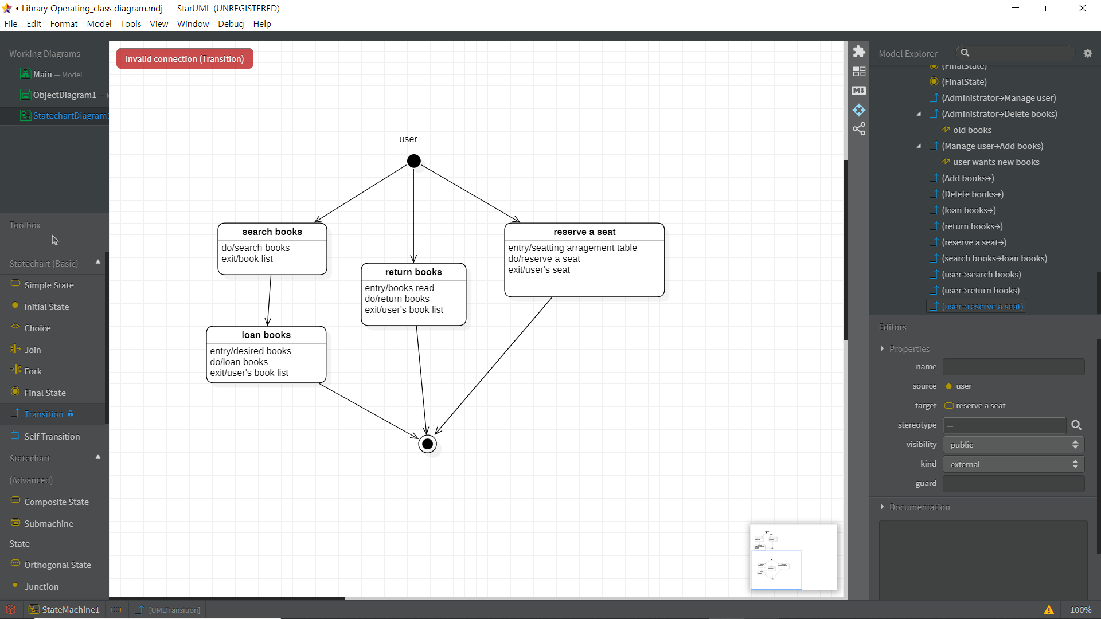**<User>**
   2. 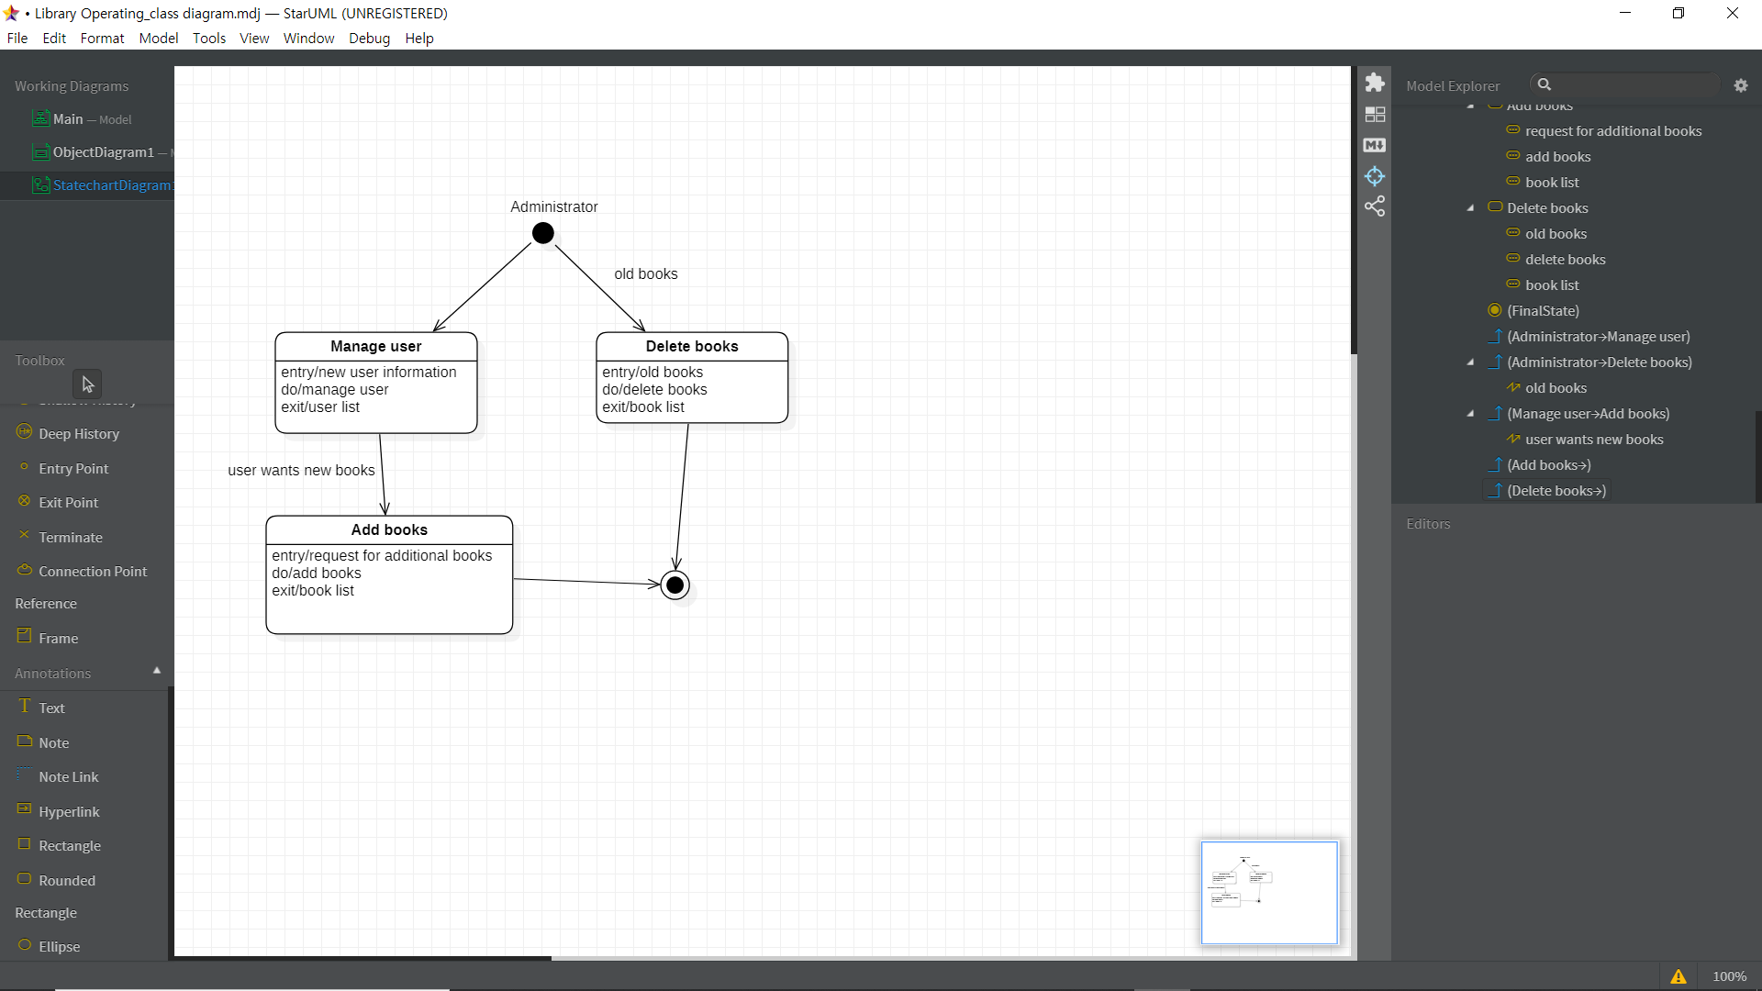**<Administrator>**